Cheat sheet:

Room 1

Click on the owl picture on the top left of the room



Click on the dog picture on the center wall



Click on cat picture on the right side of the wall

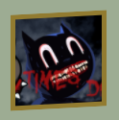

Click on the pillow at the sofa to reveal the battery, then click on the battery

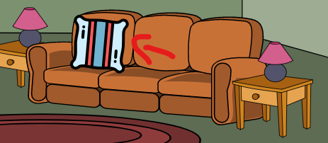

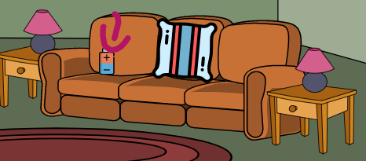

Click on the speaker and click on the insert battery button to play audio (make sure speaker is working and you can hear the soundtrack)

Count the number of cries made by the animals in the soundtrack.

Correct answer

Dog = 8

Cat =5

Owl =4

Click on the lock and enter the code (854) to proceed to room 2

Room 2

Click on the sudoku puzzle on the green board to the left of the room

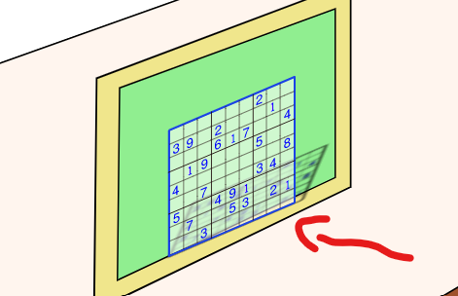

Open the console on the browser to check which version you are on as we have 3 different versions

For version 0 (row by row, left to right):

1, 6

5,3

3,4

5,1

4,2

3,5

7,9

8,7

8,6

For version 1 (row by row, left to right):

3,9

1,2

4,2

1,7

3,8

5,2

2,5

1,5

5,3

For version 2 (row by row, left to right):

5,1

5,7

1,6

2,7

6,9

1,8

5,3

7,1

7,5

Upon completion of sudoku puzzle, take down the text given

Click on the puzzle piece on the floor to play the sliding puzzle



Press s to start the game

After 10 moves, the give up button would appear, click on it to skip the puzzle

Upon completion of sliding puzzle, take down the text given

Click on the potted plant to get both the cipher alphabet and cipher key take down the string and key

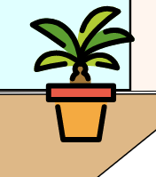 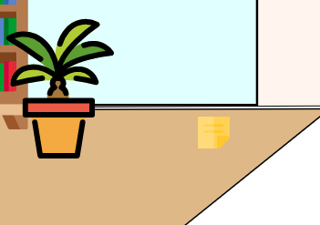

Click on the sun disk to access the cypher machine

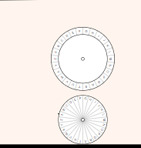

Replace the first text input with the alphabet string taken down previously (cheat: open the browser console to obtain the alphabet)

Replace the third text input with key taken down previously (cheat: open the browser console to obtain the key)

For each of the text obtained from the puzzles:

Replace the second text input with the individual text obtained previous (cheat : open the browser console and check the puzzle 1 encrypted text and puzzle 2 encrypted text)

The decrypted text would be a color and a number (take down the values for the bookshelf later. The decrypted text could also be found in the console named puzzle 1 decrypted text and puzzle 2 decrypted text)

Click on the book shelve



Use the decrypted text to click on the correct books.

Add the page number of the two books together to get the final padlock code. If the sum is less than 4 digits, pad the front with 0s. (cheat: use the browser console to obtain the pin under “correct pin:”

Click on the lock and enter the code to proceed to room 3

Room 3

Press the hanged man to play the hangman game (cheat: open browser console to get hangman answer)

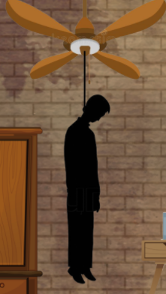

Take down the key word “multiply” and the location given .

Click on the circuit board below the computer desk

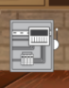

After starting the puzzle, open up the console, the answer is logged there, take note the first square is 0 and the counting sequence proceeds vertically. After completing the circuit board, the computer should now work



Click on the newspaper on the wardrobe, find the date and time on the newspaper and note it down.



Click on the computer on the desktop, click on the first icon



Input the date and time into the respective columns

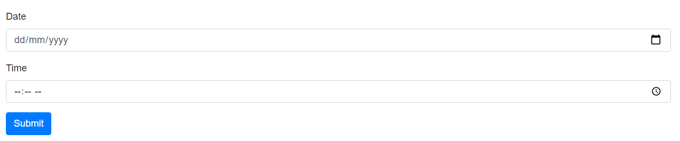



You will see cards containing locations. Find the card with the location obtained above.

Multiply the Latitude, Longitude and Temperature together and remember the code (first 4 digits).

Click on the third icon on the computer and key in the 4 digit code.



Take down the title of the news article shown.

Click on the second icon on the computer



Find the article which match the title given above and take note of the author’s name

Press on the words “WHO MURDERED ME” to guess the murderer (cheat: murderer name in the console as well).

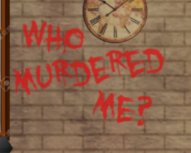

END